Name:____________________________________________ Date:________________ Period: _______
Quiz 1A – Work/Energy (10 Points) - Regular
The diagram below shows a 20 g ball loaded on a spring launcher that travels along a frictionless ramp with no air resistance. The various ball positions are denoted with the numbers 1-6. At Position 1, the ball is at rest, and the spring is fully compressed. At Position 3, the ball has left the spring launcher. Position 5 is at a height of 0m, and the height of the spring launcher is 3m. The ball stops at Position 6.
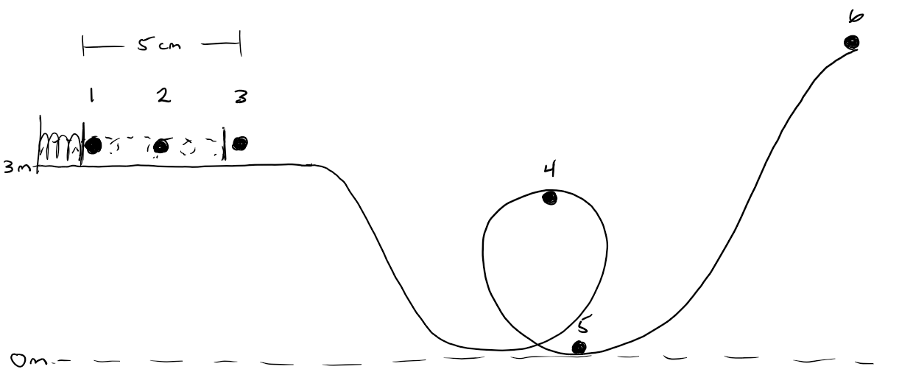

1) Compare the energy at each position by putting a <, >, or = sign in the blank:
1 ________ 2 ________ 3 ________ 4 ________ 5 ________ 6

2) What kind of energy does the ball have at each position:
1: ________________________________________________________ 4: ______________________________________________________
2: ________________________________________________________ 5: ______________________________________________________

3: ________________________________________________________ 6: ______________________________________________________

3) A total force of 12 N is needed to load the spring 5 cm (from Position 3 to Position 1). What is the spring stiffness?

4) The ball is traveling at 9.42 m/s through Position 5. What is the elevation of Position 6?

